  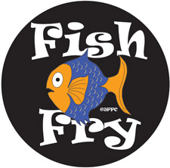
    - Starting ON:
    - FEB. 20th, 2015
  Best Friday Fish Fry in Fairport:
  Fresh Breaded Deep Fried Haddock Fillet, French Fries, Cole Slaw, Roll & Butter
  Located at St. John of Rochester Church on the corner of Route 31 and Wickford Way. Go to the school building next to the Gym in the back parking lot and enter through the school’s double doors. Watch for the signs. Thank you.
  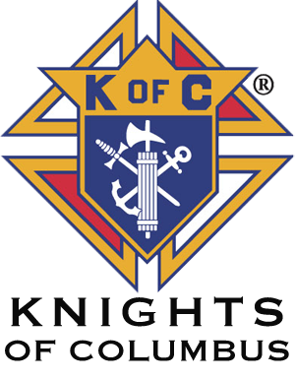 Rev. Michel C. Hogan Council 15917
  FRIDAY FISH FRY
  St. John of Rochester Parish Center
  TAKE OUT ONLY!
  Take Out Dinners Served Every Friday During Lent
  4:30 PM to 7:30 PM
  PRICE: $11.00 Cash only Please
  Knights of Columbus
  8 Wickford Way, Fairport, NY 14450
  Serving Take Out Dinners 4:30 PM to 7:30 PM
  Feb 20, 27, March 6, 13, 20, 27 & April 3

