
HYS Unified Soccer Program
WHO: | Youth ages 12-15 with and without intellectual disabilities
WHAT: | A FREE, inclusive soccer program focusing on using sport as the catalyst for building friendships and achieving social inclusion through Special Olympics Unified Sports and Holden Youth Soccer
WHERE: | Mountview Middle School, Holden, MA 01520
WHEN: | 8 week Fall Session: Sundays, August – October 30, 2018  From: 10:00am to 11:00am
Visit: | www.holdenyouthsoccer.org and www.specialolympicsma.org/ for further details

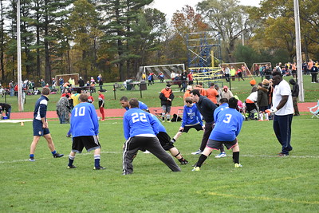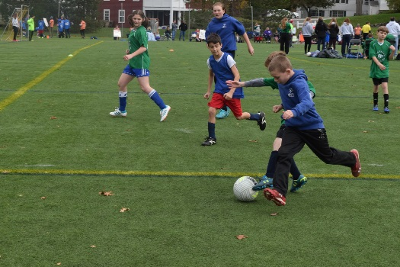
Register Today @ www.holdenyouthsoccer.org
Go to the Registration tab and look for “2018 Unified Soccer”
Registration questions?
Please email Jon-Paul St. Germain, Holden Youth Soccer at jonpaulstgermain1@gmail.com or call Matt Vaghi, Special Olympics MA at 508-485-0986

