2016 Change – Age Groups
What is changing nationally and why?
US Youth Soccer is changing the way players are grouped by age. In the past, the age cutoff was in August/September to align with the school year. Going forward, the US Youth Soccer age cutoff will be January 1 (called “birth year”). The purpose is to align US Youth Soccer throughout the country and the rest of the world. This is especially important for elite players that play in international competitions.
So, what does this mean for West Boylston Youth Soccer?
Full implementation of the “birth year” approach would split classes in half. This would typically mean that kids born between 9/1 and 12/31 would play in a younger group that those born between 1/1 and 8/31.
Mass Youth Soccer has decided to take a slightly different approach to implementing the mandate from US Youth Soccer by changing to “Grade Groups” instead of age-based groups. While there still is an age component, the groupings are driven by school grade. Mass Youth Soccer believes that town-based recreational programs (such as WBYSA) should be able to keep classmates together.
How will registration be different for Fall 2016?
You will be asked to specify the “Grade as of Fall Soccer 2016” during the registration process. This will be used to help appropriately place your child. However, the system we use (Sports Manager) is not capable of handling “grade groups” and will therefore continue to separate based on age. We will use the “Grade” information to help identify any kids that may be misplaced.
Below is a simple chart showing how WBYSA will be grouping our players. Use this chart to confirm that your child has been assigned to the correct group.

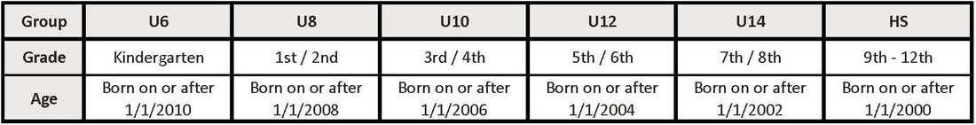

​​Wait a minute….I thought the groups were based on grade? What are the “U” groups doing here?
Old habits die hard. Our travel league (MAYS) has decided to keep the “U” designations for now even though “U10” no longer means “Under 10”. Just a bit of extra confusion.
Is there anywhere I can go for more information?
I would recommend reading the statement from Mass Youth Soccer about this change (link below). This is a pretty good summary of the national change as well as the approach of Mass Youth Soccer: Mass Youth Soccer - Statement on US Soccer Birth Year Mandate

