Good Afternoon,
My name is Ian Hunt and I am the new Risk Manager for Woburn Youth Soccer. Over the next few days, I will be sending out several emails breaking down the 3-step process that needs to be completed by all adults associated with Woburn Youth Soccer. The 3 steps are 1) Adult Registration with Mass Youth Soccer and CORI check; 2) Concussion Course through the CDC; and SafeSport Course.
This email will address the Step 1, registering with Mass Youth Soccer and submitting your CORI background screening. It’s a two for one step.
First, thank you for participating in the Woburn Youth Soccer Fall 2022 - Spring 2023 soccer year. All participating adults (persons age 18 and older - excluding Adult Athletes) must complete an Annual Mass Youth Soccer Adult Registration and possess an Adult Credential.

To complete your Adult Registration click the following link: U.S. Soccer Connect Adult Registration Portal. (Screen shot below)

To Register, click on the icon Register Now!.
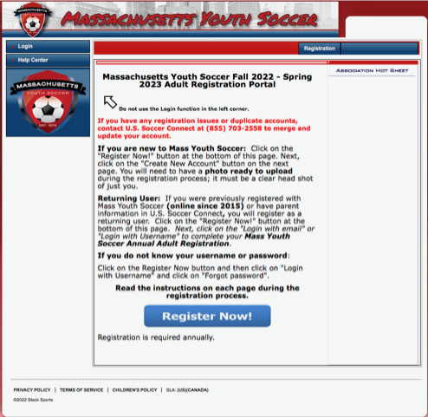
Please complete your required Mass Youth Soccer Annual Adult Registration as a returning user. If you run into difficulties, do not create a new/duplicate account. For assistance, contact the U.S. Soccer Connect Support Team at (855) 703-2558.

Please use your previous login credentials. Your previous Login credentials is either your email address or a username that you used when you previously created your account. If you don’t remember which one you used, try your email address.



When registering, make sure your organization choice(s) are up to date.
- Instructions on how to complete your Mass Youth Soccer Adult Registration as a returning registrant and completing the required trainings can be found in the Adult Registration - Returning User Help Guide.
- Instructions on how to complete your Mass Youth Soccer Adult Registration as a new registrant and completing the required trainings can be found in the Adult Registration - New User Help Guide
Returning Coaches Select Returning User (Green Returning User Button):
Adults who have previously completed a Mass Youth Soccer Association Online Adult Registration.
New Coaches Select New User (Blue Create New Account Button):
Adults who have never completed a Mass Youth Soccer Adult Registration online.
- Make sure to have a drivers license or passport quality head shot photo of only you ready to upload during the Adult Registration process.
- The registration system may find uploaded information for you and prompt you to register as a returning user.
- To be eligible to complete your Adult Registration as a coach/volunteer, you MUST sign in using your adult registration username and password.
- If you are unsure as to how to proceed, call the U.S. soccer Connect Help Line at (855) 703-2558 or submit a ticket using the help link in the top left corner of the registration landing page.
YOUR REGISTRATION IS COMPLETE WHEN YOU RECEIVE AN EMAIL FROM MASS YOUTH SOCCER WITH THE SUBJECT "Thank you for Registering, YOUR NAME".
IF YOU DO NOT RECEIVE THIS EMAIL WITHIN 5 TO 10 MINUTES, YOU MUST GO THROUGH THE REGISTRATION PROCESS AGAIN!

The Confirmation email only means you’ve completed Step 1 but still may need to do SafeSport and Concussion classes!!!!!!

Thanks,
Ian Hunt
Risk Manager
Woburn Youth Soccer

